Lab 5 Understanding ACLs & Firewalls

Stateful vs. Stateless Firewalls

Stateful firewalls track active connections in a table and apply security rules based on the context of ongoing traffic, making them more secure and context aware. Examples include IPTables and Windows Firewall. In contrast, stateless firewalls inspect each packet independently without tracking connections, applying predefined rules to each packet, which makes them simpler and faster but less aware of traffic context. They're often used in environments where speed is prioritized over detailed traffic analysis.

Step 1. Launch Ubuntu machine

Step 2. Log in as sysadmin using the password provided.

Step 3. Open terminal

Step 4. To explore the IPTables enter the following command: iptables -h

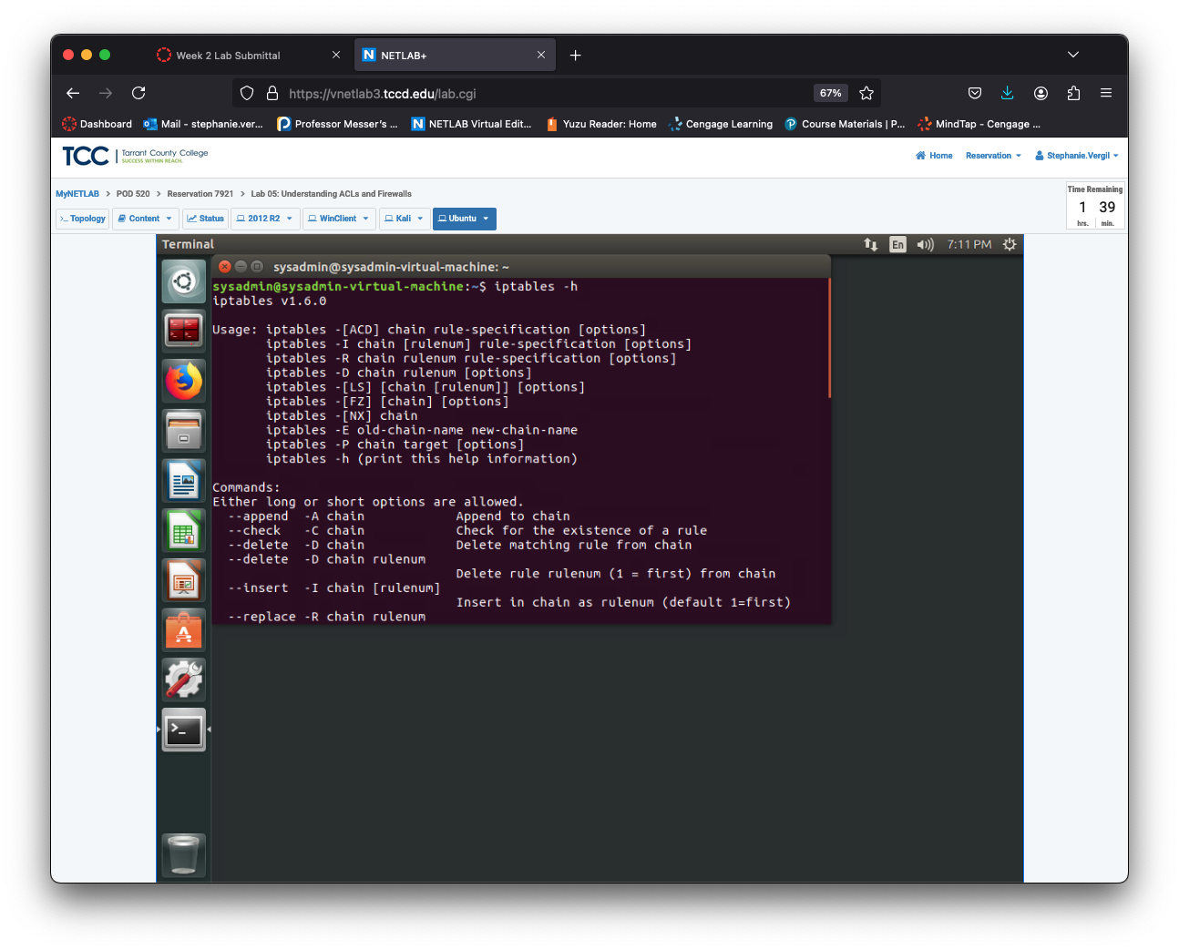

Step 5. To view a more detailed overview enter the following command: man iptables

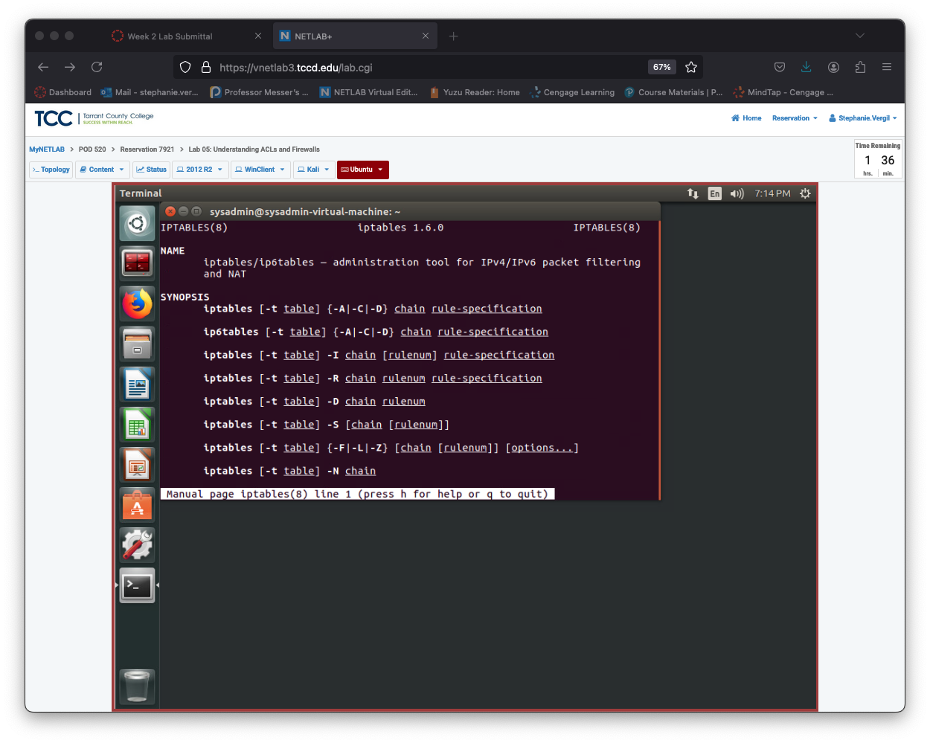

Setting up IPTables

As a stateful firewall, IPTables tracks and manages connections. In this task, I’ll clear all existing IPTables rules and practice setting up basic rules to block unwanted traffic while allowing traffic on certain ports.

Step 1. I first have to begin by viewing the rules currently existing in the IPTables chains. By entering the following command: sudo iptables -L

The -L switch lists all the rules in each chain

Step 2. To avoid problems from old rules, it's best to start fresh. Chains are just lists of rules. To clear all the rules in IPTables, type this: sudo iptables -F

Step 3. Examine the results of flushing IPTables by entering the following command. Notice that there are no longer any chains. sudo iptables -L

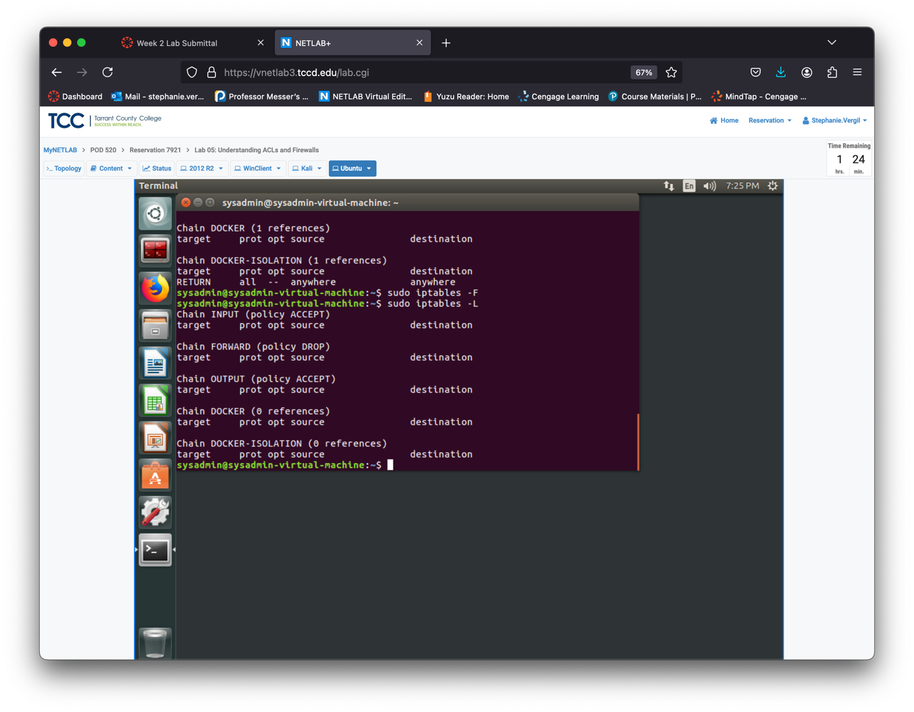

Step 4. Test icmp functionality by pinging the Kali machine with the following command:

sysadmin@sysadmin-virtual-machine:~$ ping -c4 192.168.1.3

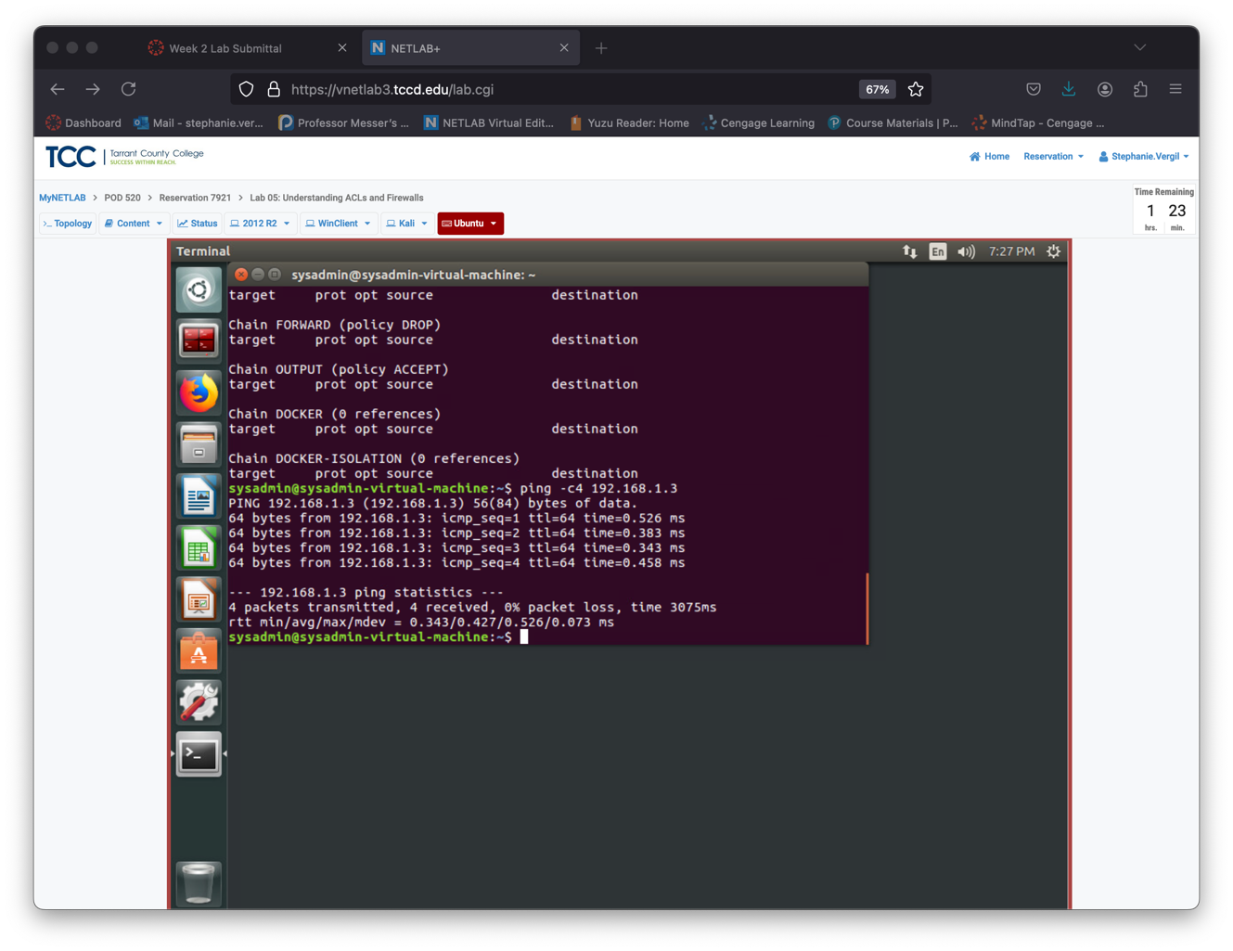

Step 5. Launch Kali VM

Step 6. Enter username and password

Step 7. Launch Terminal

Step 8. It is important to test pings both ways for icmp connectivity, since rules allow or block both inbound and outbound traffic by entering the following command:

ping -c4 192.168.1.4

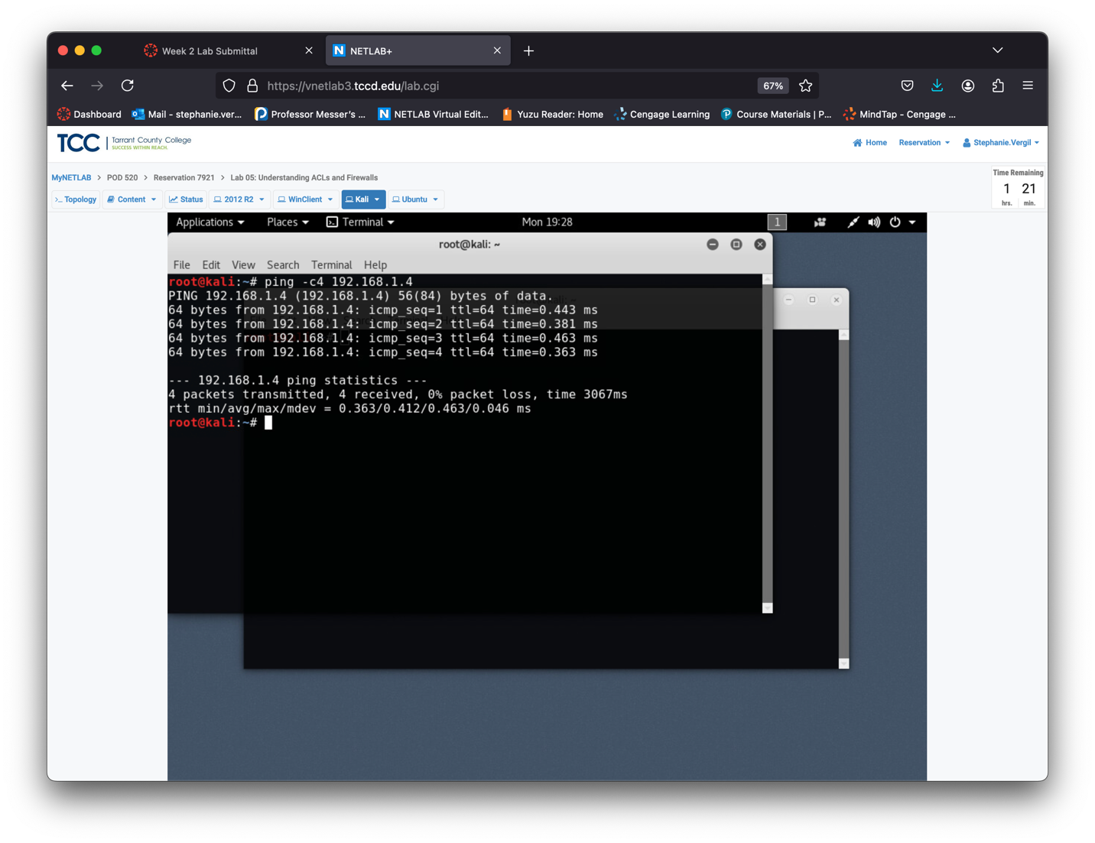

Step 9. Return to Ubuntu

Step 10. Set up your firewall with a basic "deny all" rule. This blocks all incoming and outgoing traffic, providing a secure starting point. From here, you can selectively allow only the traffic you want. Begin by using the following command to block all incoming traffic: sudo iptables -P INPUT DROP

Step 11. Use the following command to drop output traffic: sudo iptables -P OUTPUT DROP

12. To drop forwarded traffic, enter the following command: sudo iptables -P FORWARD DROP

Note: These commands take effect right away. If you enter them directly, you'll cut off network connectivity and lose remote access, which is problematic if you're configuring the firewall via SSH.

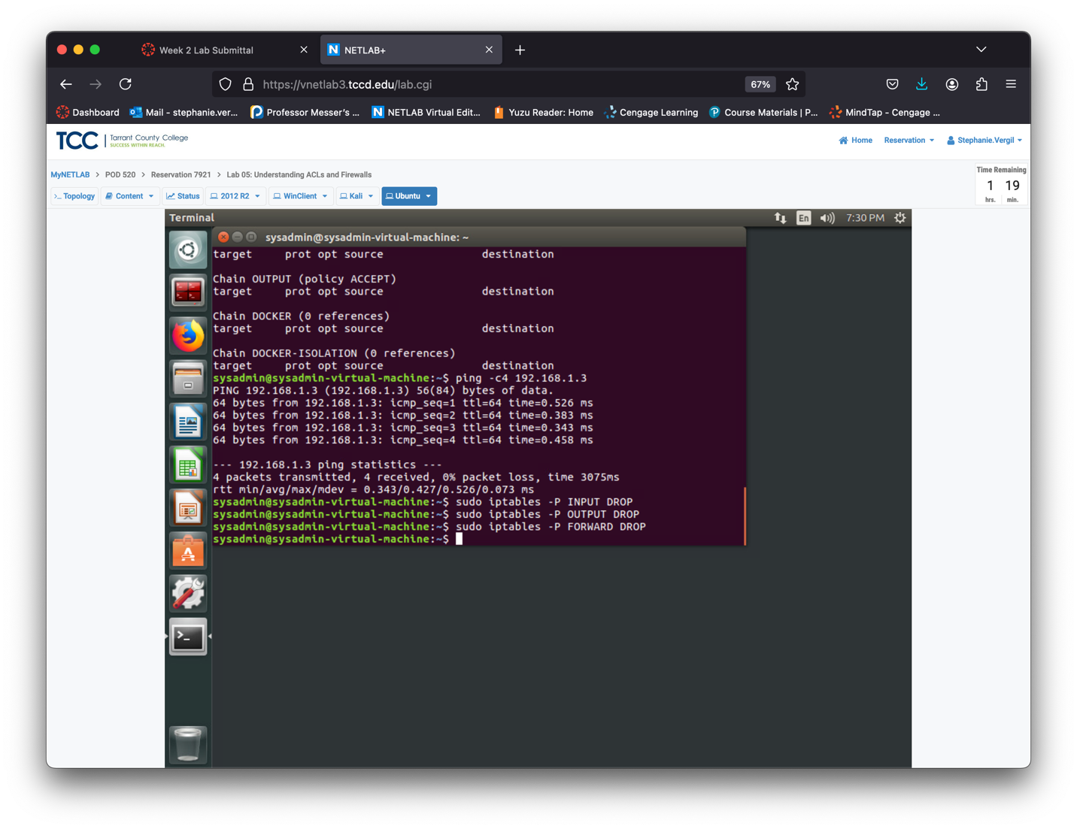

Step 13. To view the chains you just created, enter the following command: sudo iptables -L

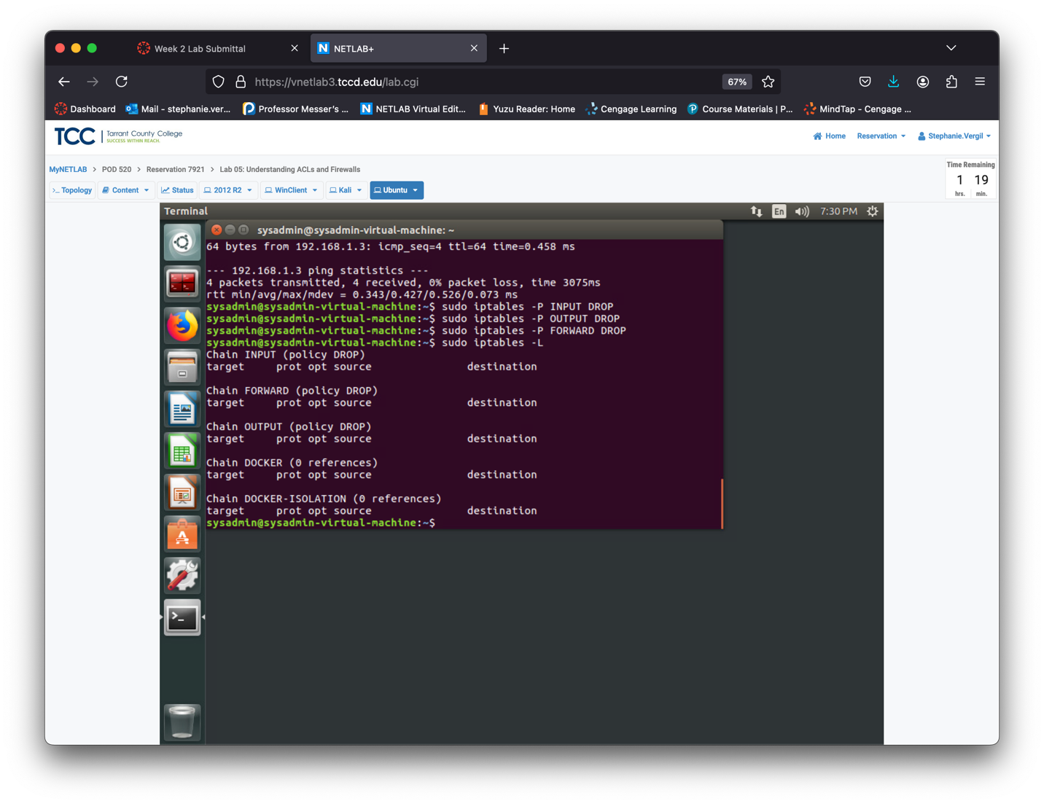Step 14. Test ICMP connectivity to the Kali machine again. You'll see different messages now because you're blocking outgoing traffic, which results in an "operation not permitted" error. Enter the following command: ping -c4 192.168.1.3

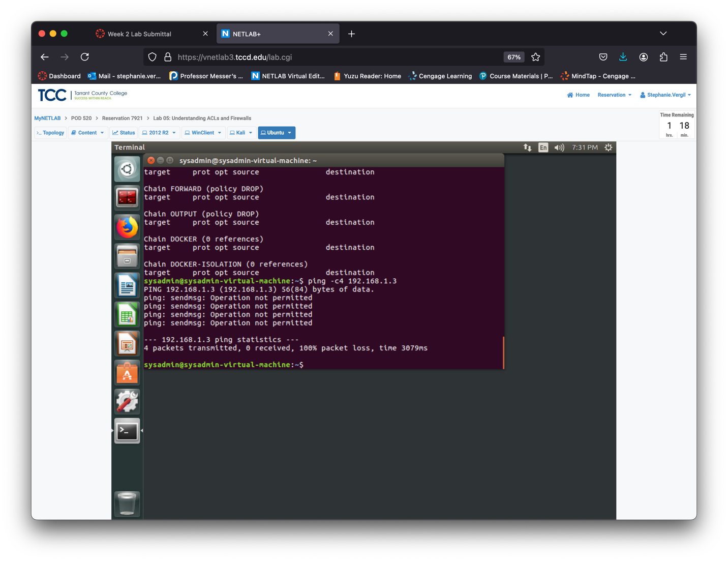

Step 15. Return to Kali

Step 16. Enter the following command: ping -c4 192.168.1.4

to test icmp connectivity to the Ubuntu machine.

Since the traffic is blocked on the Ubuntu machine rather than the Kali machine, you do not receive an operation not permitted message. However, the ping is unsuccessful.

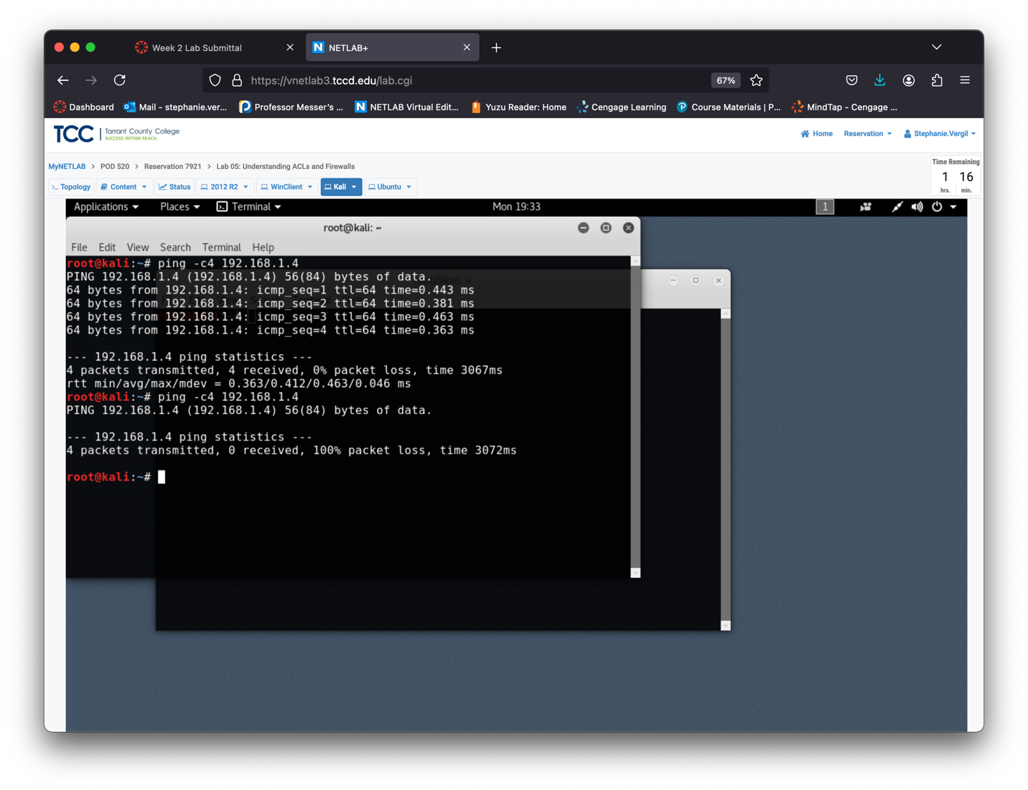

Step 17. Return to Ubuntu

Step 18. Ping the loopback interface with the following command: ping -c4 127.0.0.1

Notice that the operations still not permitted

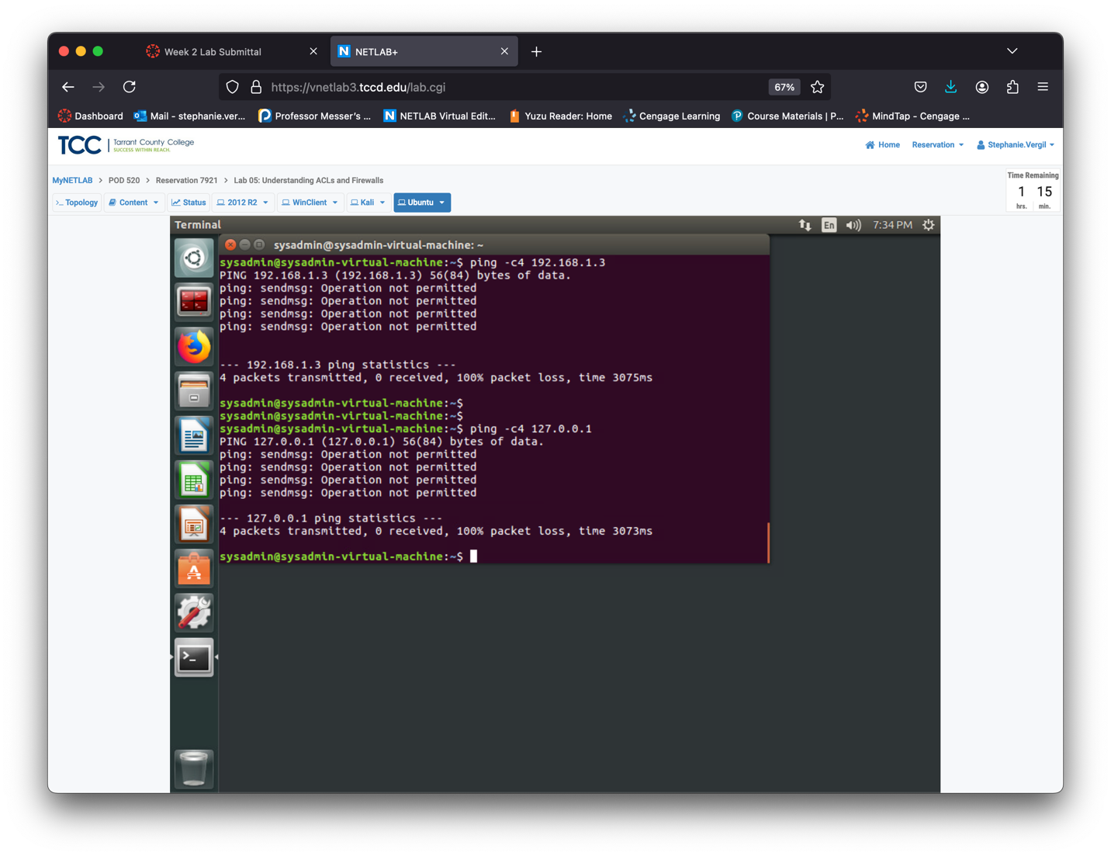

Step 19. Allow outbound traffic to the loopback interface only with the following command: sudo iptables -A OUTPUT -o lo -j ACCEPT

Note: The -A (or --append) chain rule-specification appends one or more rules to the end of the selected chain. When the source and/or destination names resolve to more than one address, a rule will be added for each possible address combination.

Step 20. After allowing output traffic, test the loopback interface again. The ping will still fail because returning traffic is not allowed, but the operation will be permitted. Enter the following command: ping -c4 127.0.0.1

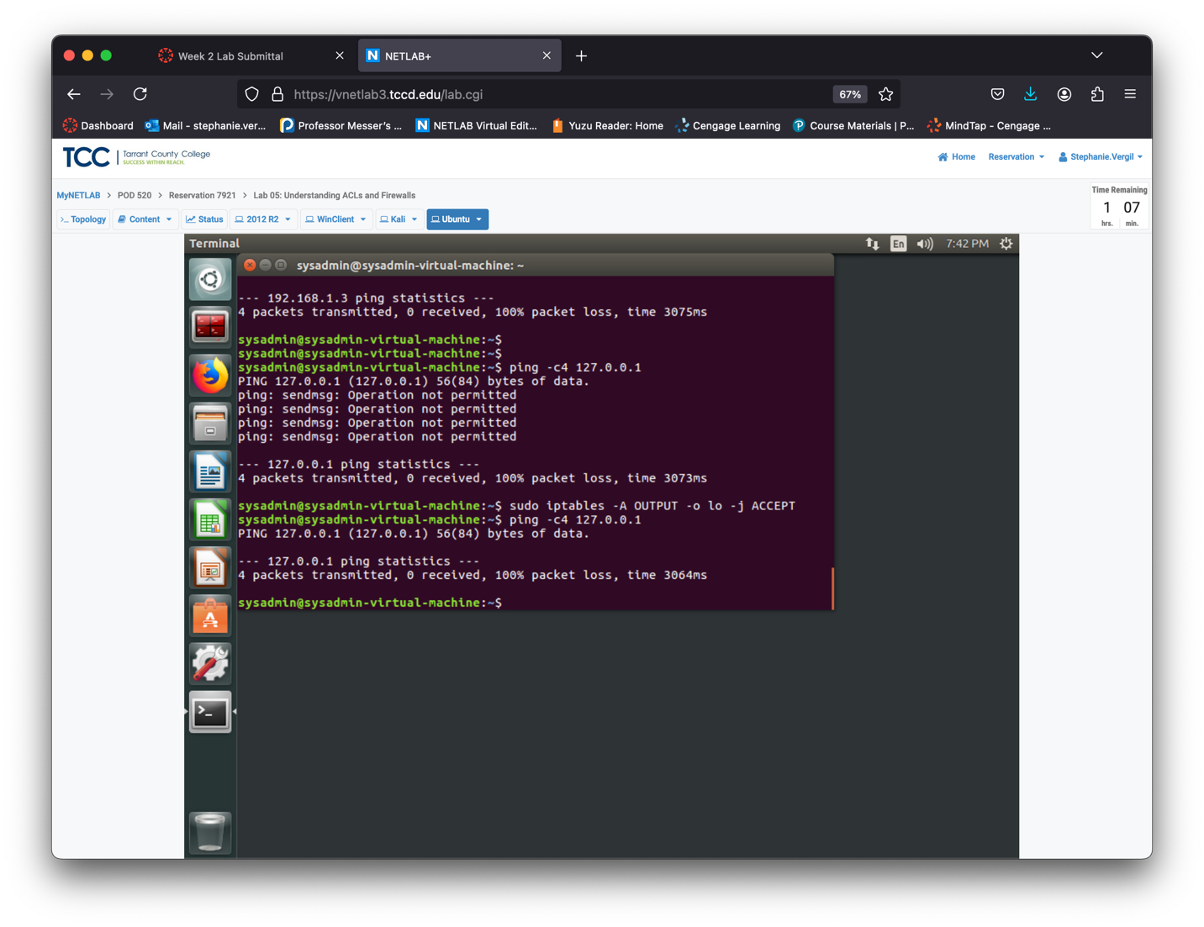

Step 21. Allow incoming traffic from the loopback interface with the following command: sudo iptables -A INPUT -i lo -j ACCEPT

Step 22. Any traffic with an IP address in the 127.0.0.0/8 range that isn’t on the loopback interface is spoofed. Drop this traffic with the following command: sudo iptables -A INPUT -s 127.0.0.0/8 -j DROP

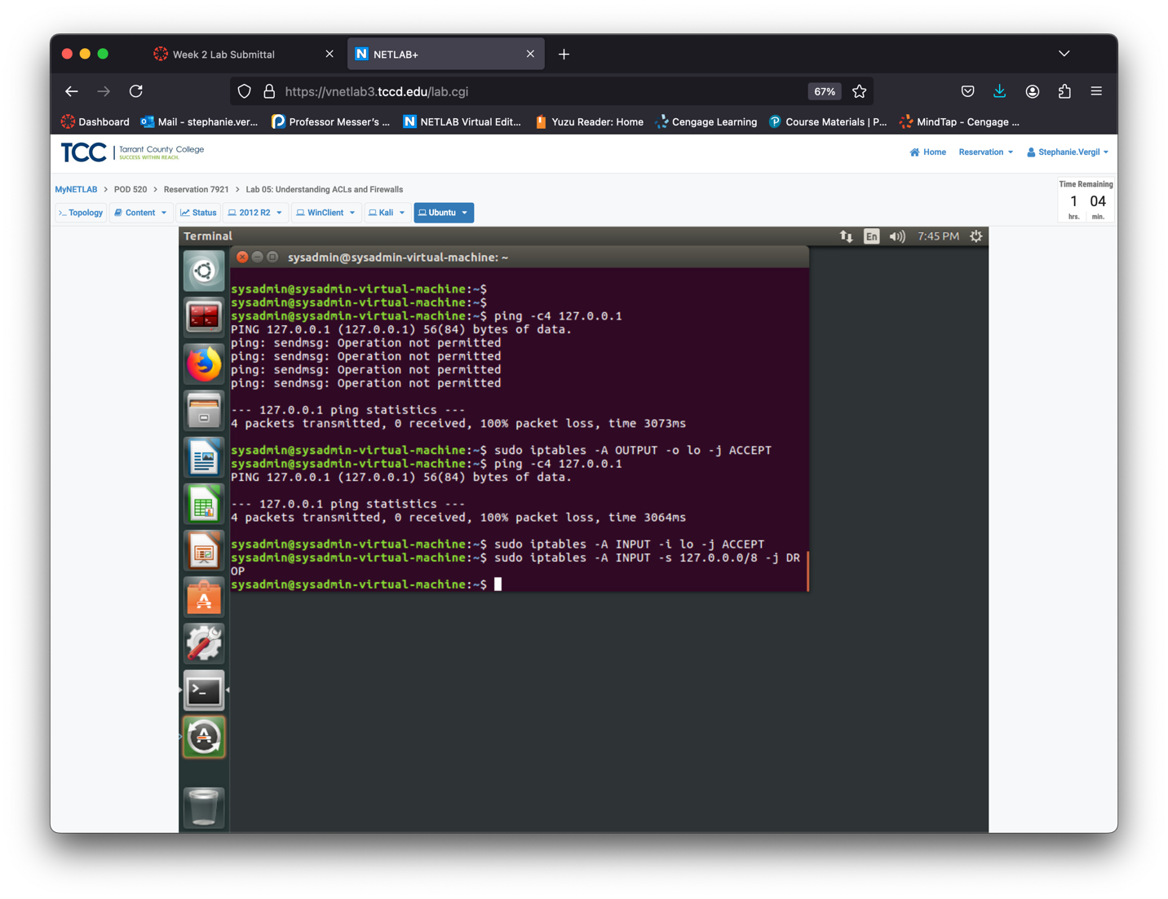

The switches for setting interfaces vary based on whether you're configuring input or output chains:

-i (or --in-interface): Specifies the interface a packet came in on (for INPUT, FORWARD, and PREROUTING chains).

-o (or --out-interface): Specifies the interface a packet will go out on (for OUTPUT, FORWARD, and POSTROUTING chains).

-s (or --src, --source): Specifies the source address, which can be a network name, hostname, or IP address, written in either standard or CIDR notation.

Using "!" before the interface name inverts the match. If the interface name ends with a "+", any interface starting with that name will match. If this option is not used, any interface name will match.

Step 23. Ping the Kali machine again to confirm that the action is still not permitted using the following command: ping -c4 192.168.1.3

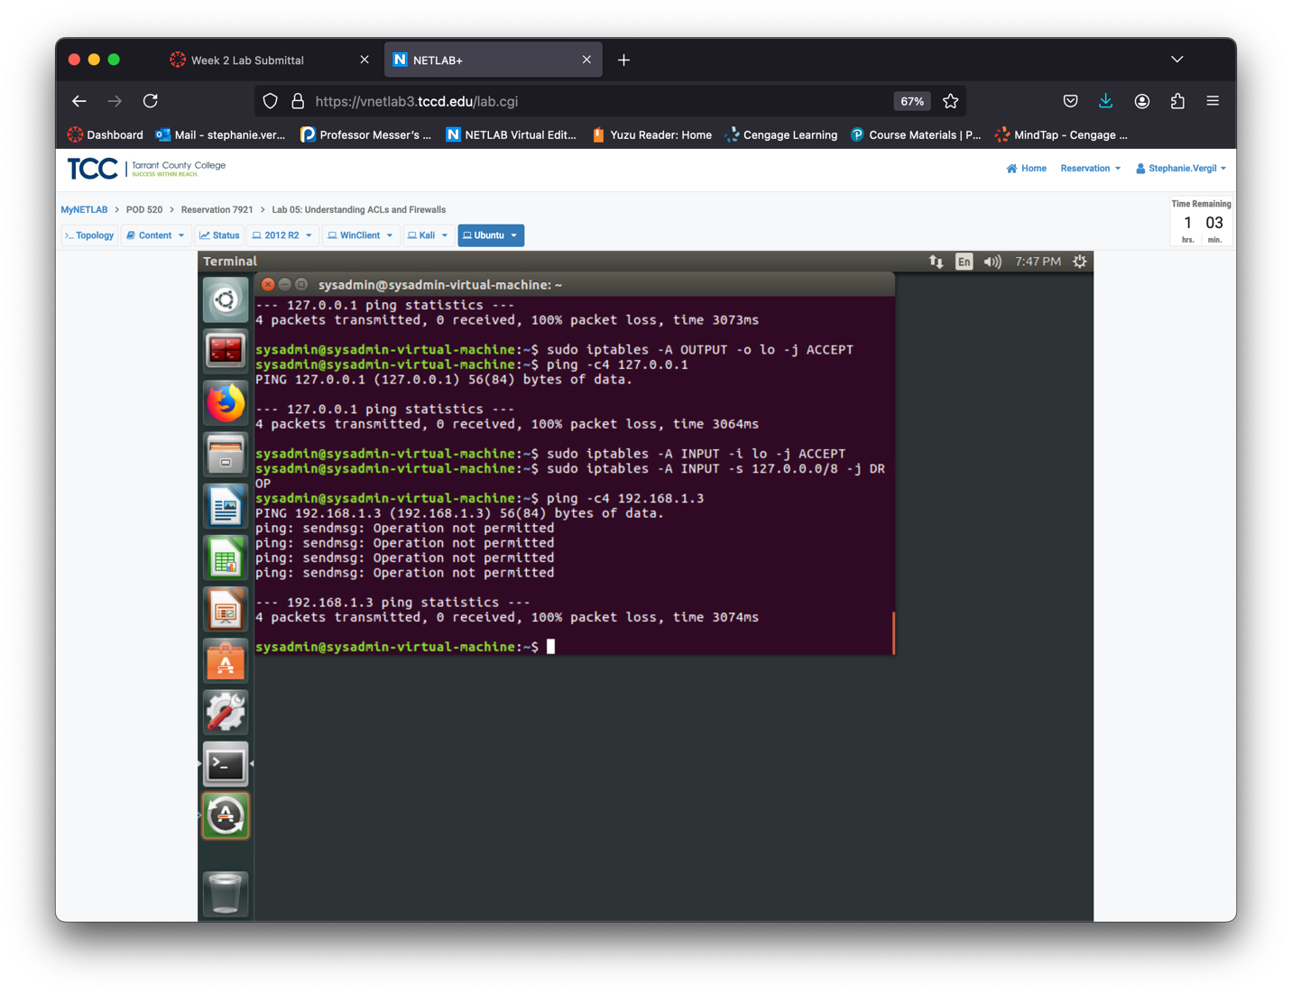

24. Now check your loopback rules, to see that they have overridden your implicit deny. Enter the following command: ping -c4 127.0.0.1

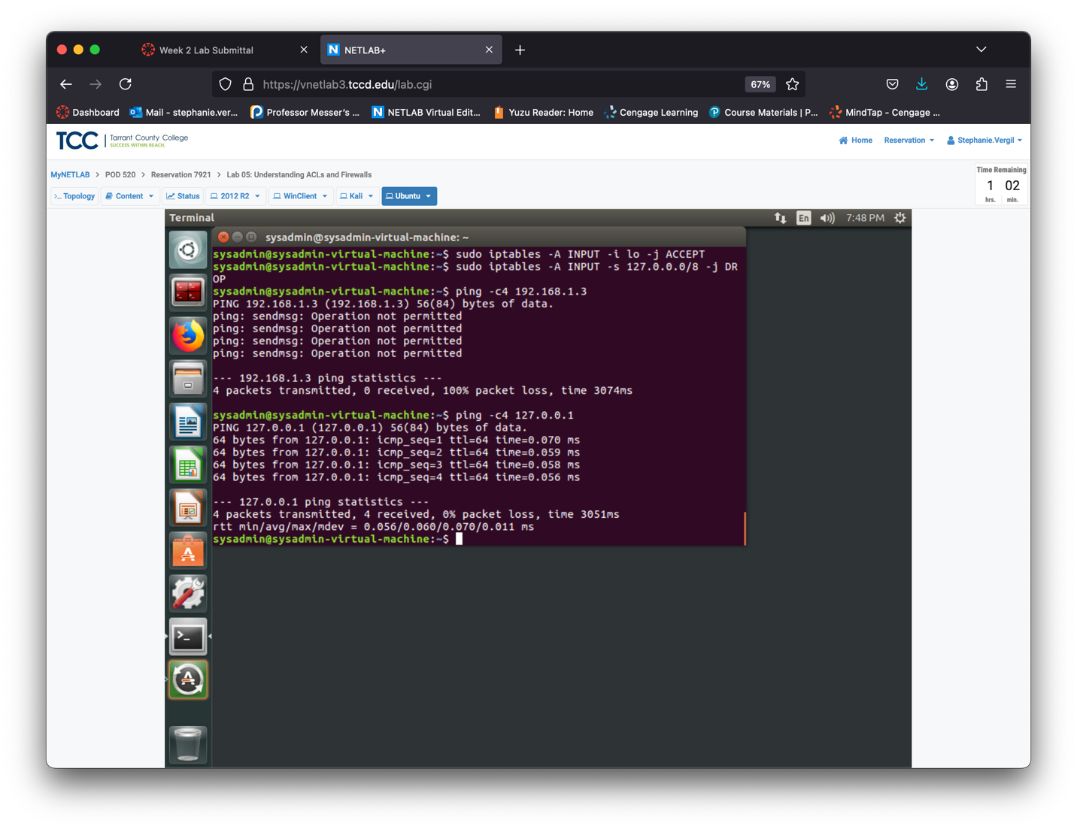

Step 25. Return to the Kali machine.

Step 26. Ensure that outside traffic still isn’t allowed to the Ubuntu machine with the following command: ping -c4 192.168.1.4

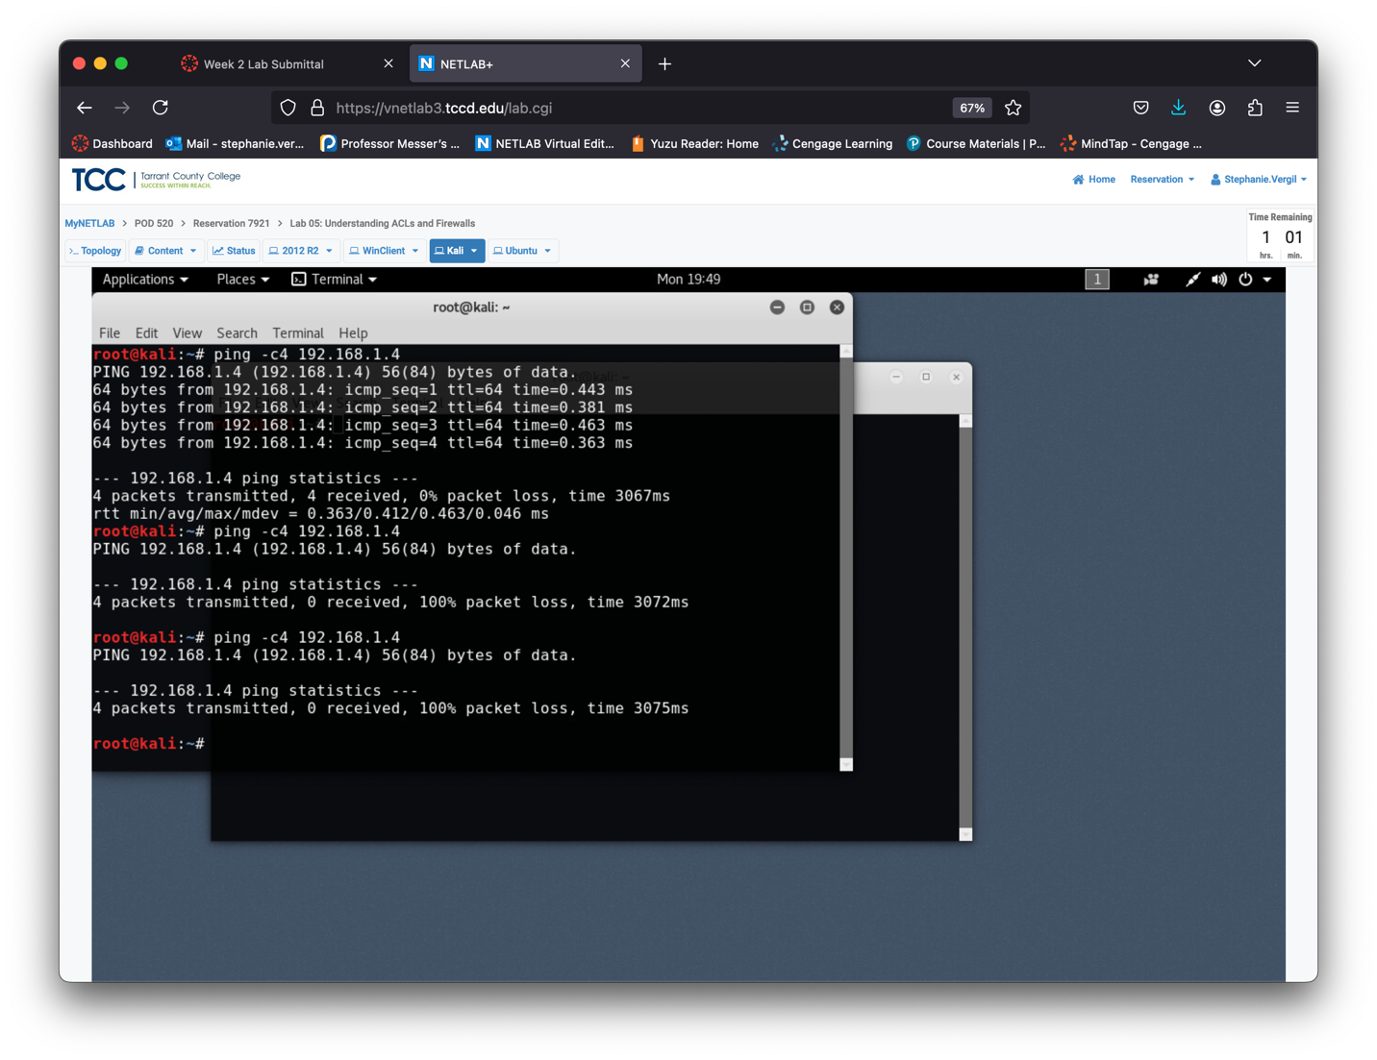

Step 27. Return to Ubuntu

Note: When allowing outbound traffic, you have several options:

-m state: Enables stateful session handling.

-p (or --protocol): Defines the protocol for the rule or packet. Options include:

"all": Matches all protocols (default if omitted).

tcp, udp, udplite, icmp, icmpv6, esp, ah, sctp, mh

A numeric protocol value.

A protocol name from /etc/protocols.

Step 28. Enter the following command to allow outbound tcp traffic from the Ubuntu machine: sudo iptables -A OUTPUT -p tcp -m state --state NEW,ESTABLISHED -j ACCEPT

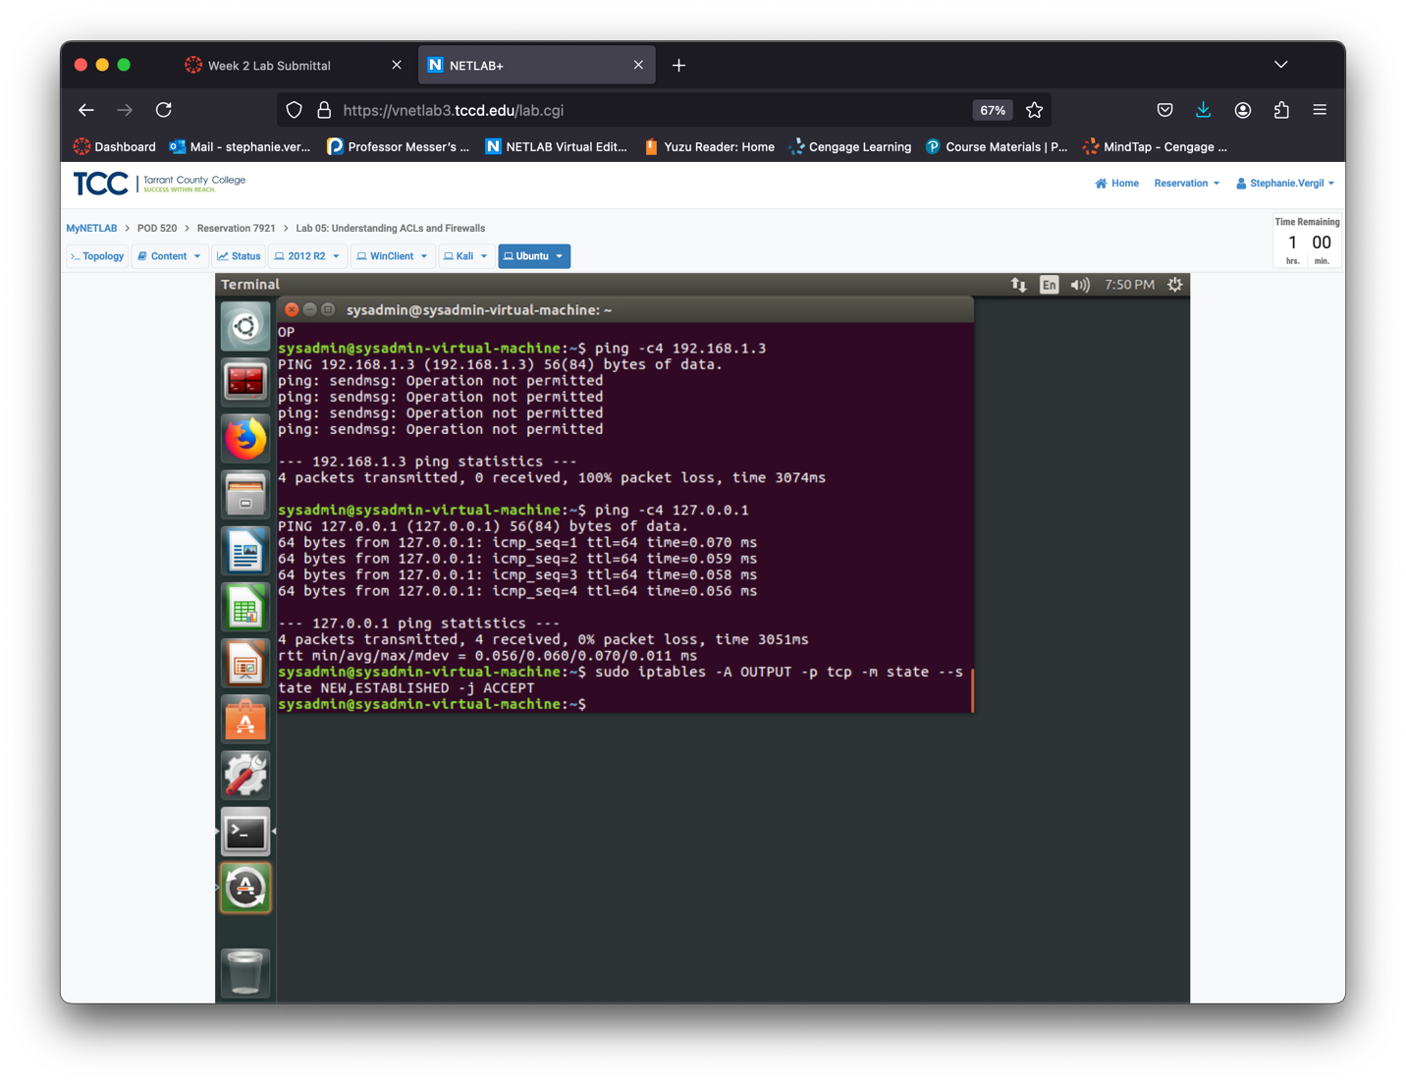

Packets can be in one of these states:

NEW: The packet is starting a new connection or is linked to a connection that hasn't seen traffic in both directions.

ESTABLISHED: The packet is part of a connection that has seen traffic in both directions.

RELATED: The packet starts a new connection related to an existing one, like an FTP data transfer or ICMP error. Handled by kernel modules for specific protocols (e.g., FTP).

INVALID: The packet cannot be identified or doesn't match any known connection state.

Step 29. Enter the following command to allow outbound udp traffic: sudo iptables -A OUTPUT -p udp -m state --state NEW,ESTABLISHED -j ACCEPT

Step 30. Enter the following command to allow outbound icmp traffic: sudo iptables -A OUTPUT -p icmp -m state --state NEW,ESTABLISHED -j ACCEPT

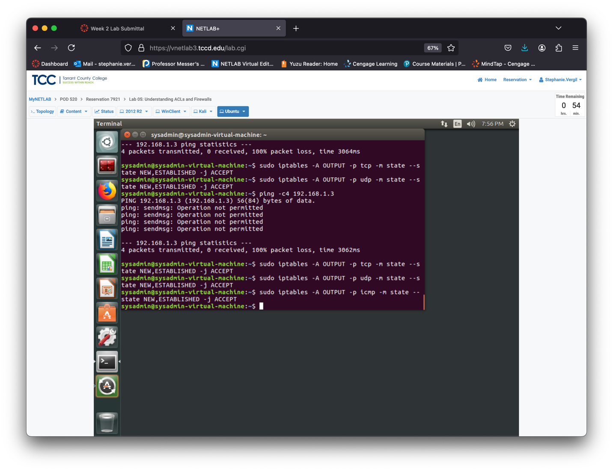

Step 31. Test if outbound ICMP traffic is now allowed with the following command:

ping -c4 192.168.1.3

Although outbound traffic is permitted, you won't receive any responses because inbound and returning traffic is still blocked by the implicit deny rule you set up

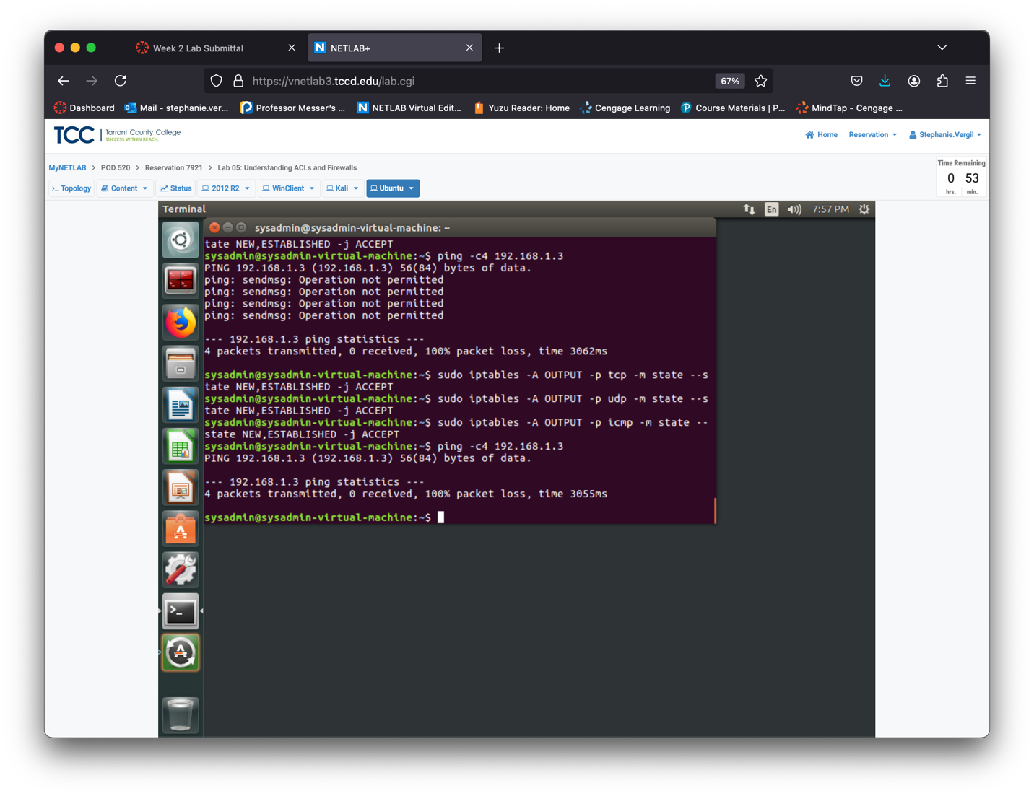

Step 32. Return to Kali

Step 33. You did not allow inbound icmp traffic, so the Kali machine should not be able to

reach the Ubuntu machine. Confirm this with the following command: ping -c4 192.168.1.4

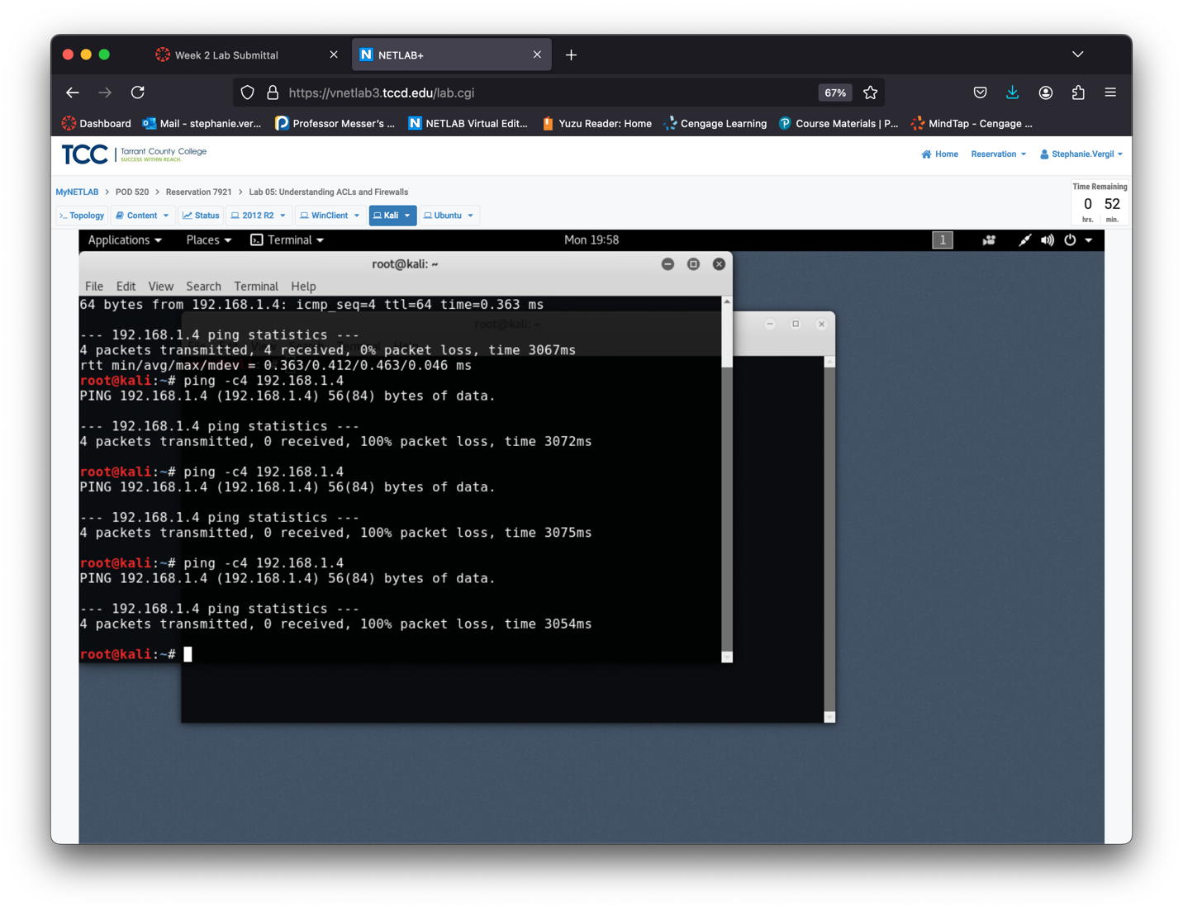

Step 34. Return to Ubuntu

Step 35. Set up a rule to allow returning TCP traffic by using ESTABLISHED (without NEW), which permits packets generated on the Ubuntu machine and are returning. Use the following command: sudo iptables -A INPUT -p tcp -m state --state ESTABLISHED -j ACCEPT

Step 36. Enter the following command to allow returning udp traffic: sudo iptables -A INPUT -p udp -m state --state ESTABLISHED -j ACCEPT

Step 37. Enter the following command to allow returning icmp traffic: sudo iptables -A INPUT -p icmp -m state --state ESTABLISHED -j ACCEPT

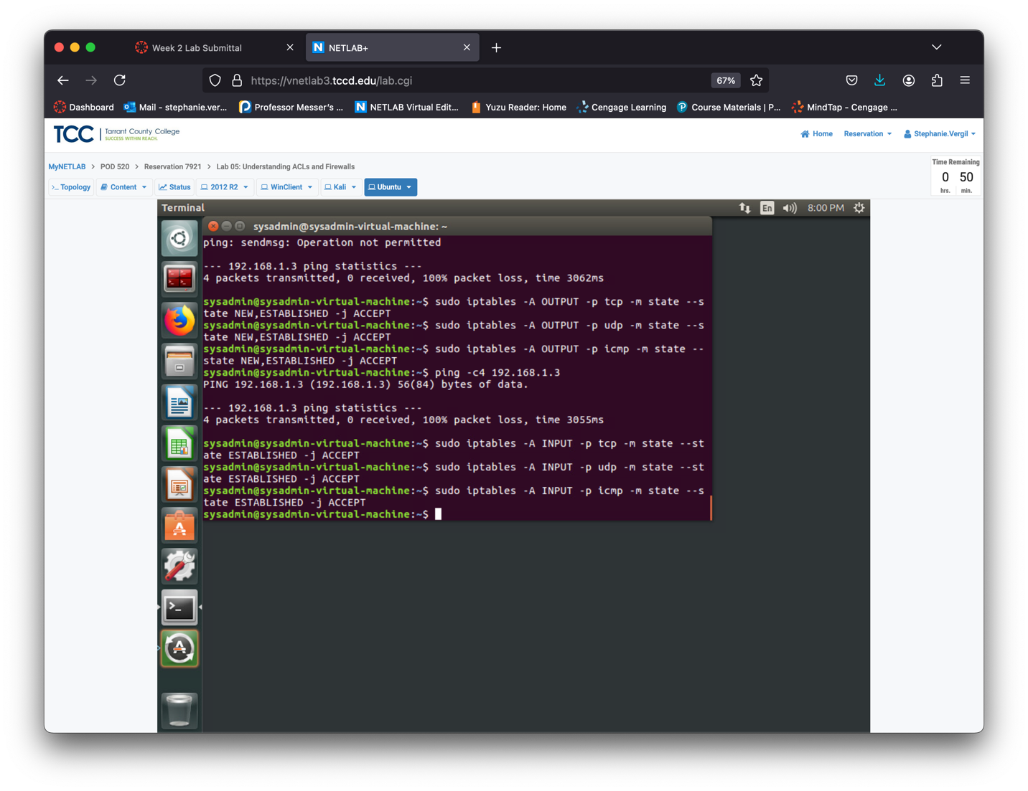

Step 38. Confirm that packets generated on the Ubuntu machine can be sent out and return with the following command: ping -c4 192.168.1.3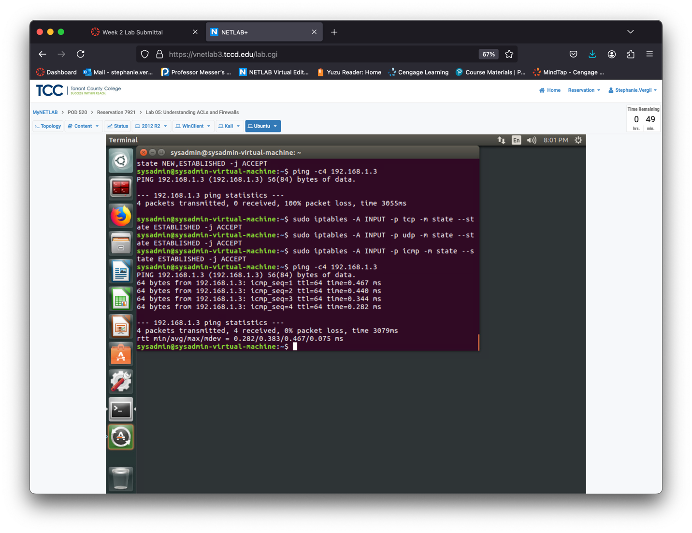

Step 39. Return to Kali

Step 40. When you ping from Kali to Ubuntu, the packet is generated on Kali, so it’s a NEW packet. Since you only allowed ESTABLISHED packets, this ping will fail. Enter the following command: ping -c4 192.168.1.4

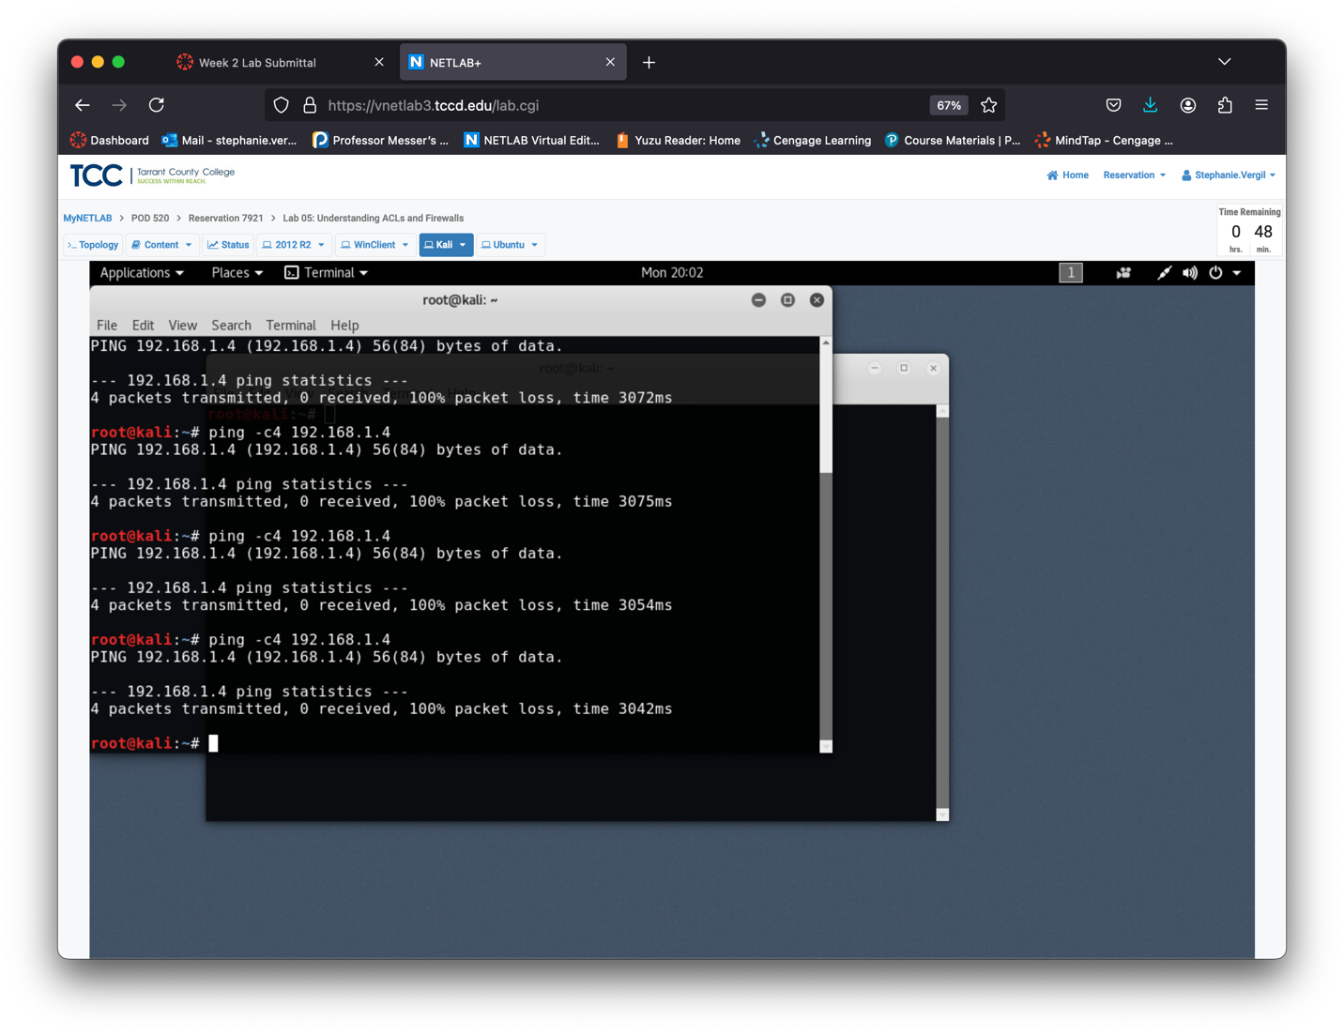

Step 41. Return to Ubuntu

Step 42 To allow incoming TCP traffic on port 21 (used for FTP). Enter the following command: sudo iptables -A INPUT -p tcp –dport 21 -m state --state NEW -j ACCEPT

Step 43. Enter the following command to test outbound connectivity on port 21. Notice that because you only allowed inbound traffic, this test fails: nc -z -v 192.168.1.3 21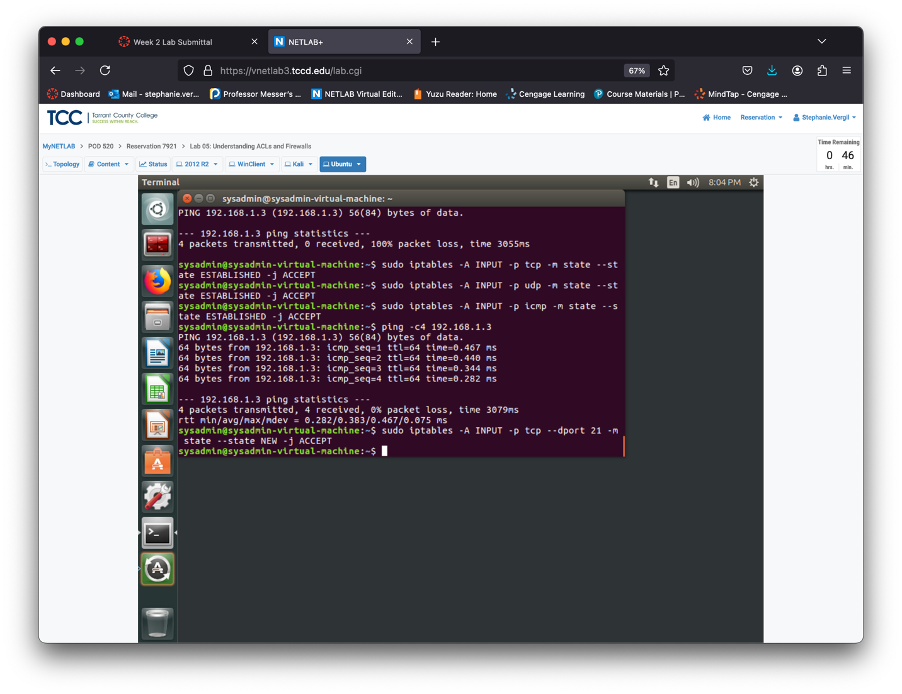

Step 44. Return to the Kali machine.

Step 45. Test the inbound connectivity for Ubuntu on port 21 with the following command: nc -z -v 192.168.1.4 21

Notice that from Kali, the command succeeds.

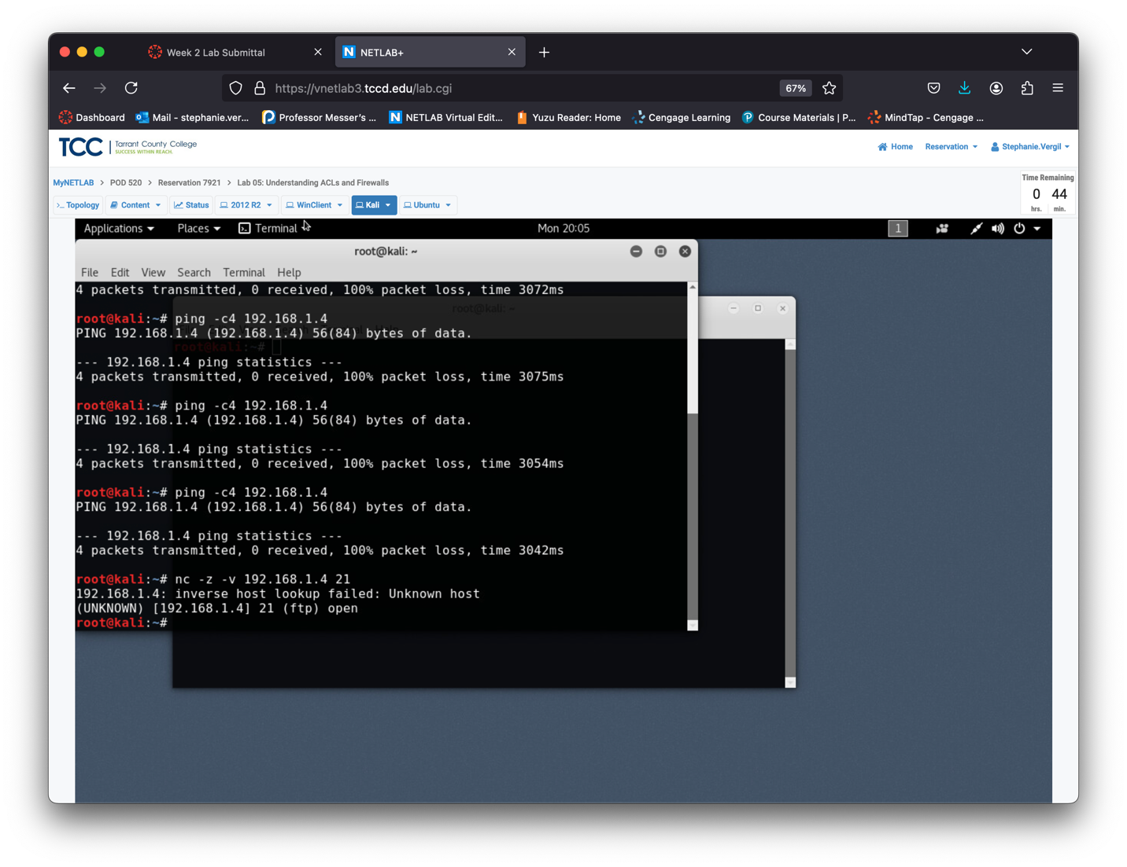Step 46. Return to the Ubuntu machine.

Step 47. Add a new rule to allow inbound http traffic with the following command:

sudo iptables -A INPUT -p tcp –dport 80 -m state --state NEW -j ACCEPT

Step 48. The following command should fail because you only allowed inbound traffic: nc -z -v 192.168.1.3 80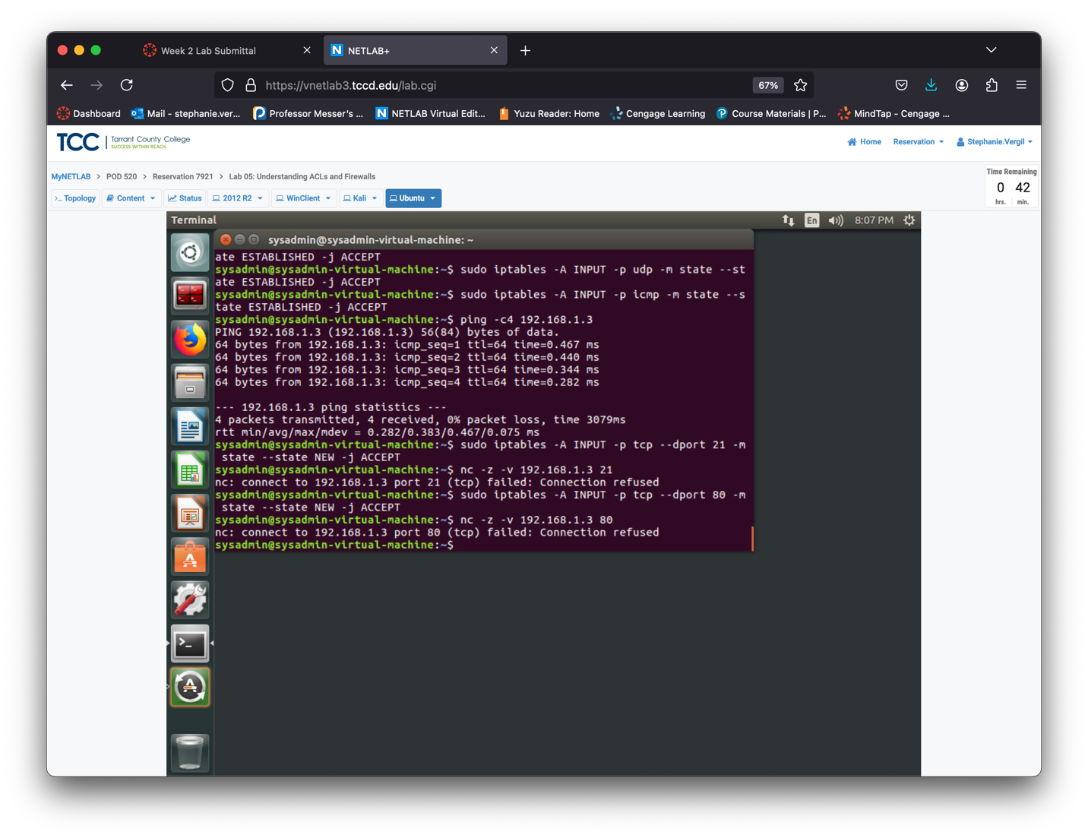

Step 49. Return to the Kali.

Step 50. Test to ensure that inbound http traffic is allowed by entering the following

command: nc -z -v 192.168.1.4 80